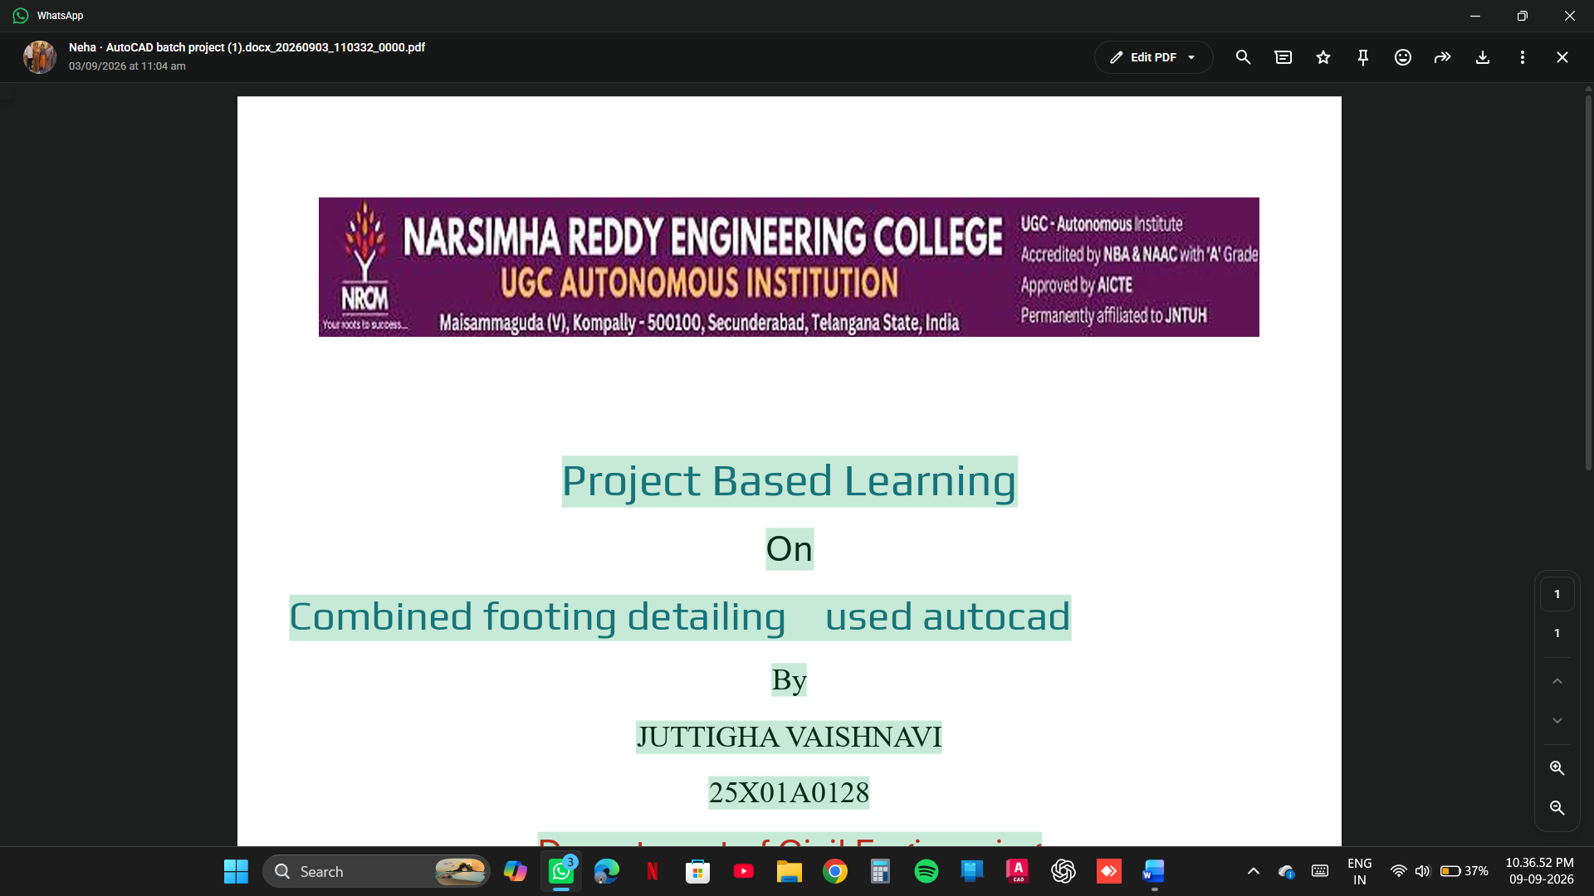
PROJECT BASED LEARNING
ON

COMBING FOOTING DESIGN AND DRAFTING BY USING AUTO CAD

BY

DUBBAKA HARSHINI 25X01A0118
KARRE AKSHAY 25X01A0130
VATTIPALLY KARTHIK 25X01A0155
NELLI MANIKANTA 25X01A0139

DEPARTMENT OF CIVIL ENGINEERING

NARSIMHA REDDY ENGINEERING COLLEGE (UGC- AUTONOMOUS) APPROVED BY AICTE, AFFILIATED TO JNTUH, ACCREDITED BY NBA & NAAC WITH A-GRADE)
MAISAMMAGUDA (V), KOMPALLY, SECUNDERABAD,500100.(20262027)

COMPUTER AIDED DRAFTING SOFTWARE PROJECT

ISOLATED FOOTING DESIGN BY USING AUTOCAD

Project Report

ISOLATED AND COMBINED FOOTING

Civil Engineering – Computer Aided Drafting
Narsimha Reddy Engineering College (NRCM)

1. INTRODUCTION
RCC (Reinforced Cement Concrete) column and footing are important structural components of a building. An RCC column is a vertical structural member that transfers loads from beams and slabs to the foundation. The footing is a foundation element that transfers these loads safely to the soil.
Reinforced cement concrete consists of concrete and steel reinforcement. Concrete provides strength against compression, while steel reinforcement provides strength against tension.
AutoCAD is a computer-aided design software used in civil engineering to prepare accurate structural drawings. It helps engineers prepare column layouts, footing plans, sectional views and reinforcement detailing.
This project focuses on preparing detailed RCC column and isolated footing drawings using AutoCAD. It includes dimensions, reinforcement arrangements, stirrups, concrete cover and sectional details.
2. PROBLEM STATEMENT
In building construction, RCC columns and footings play an important role in transferring structural loads safely to the ground.
Improper design or detailing of columns and footings may lead to structural cracks, excessive settlement and failure of structural members.
Manual preparation of structural drawings may consume more time and can result in dimensional errors.
Therefore, this project aims to prepare accurate RCC column and footing detailing using AutoCAD, showing the dimensions, reinforcement arrangement and sectional details required for construction.
3. OBJECTIVES
The main objectives of this project are:
- To understand the basic concepts of RCC columns and footings.
- To study the load transfer mechanism from columns to foundations.
- To prepare RCC column and footing drawings using AutoCAD.
- To represent longitudinal reinforcement in columns.
- To show lateral reinforcement (ties or stirrups) in columns.
- To prepare footing plan and sectional elevation.
- To show reinforcement details in both directions.
- To provide proper dimensions, labels and concrete cover details.
- To improve structural drafting skills.
- To understand the practical application of AutoCAD in civil engineering.
4. PROPOSED METHODOLOGY
The following procedure is adopted to prepare RCC column and footing detailing using AutoCAD.
Step 1: Collection of design data
Collect the required information:
- Column load.
- Column dimensions.
- Soil safe bearing capacity.
- Footing dimensions.
- Grade of concrete.
- Grade of steel.
- Required reinforcement details.
Step 2: RCC column detailing
- Select the column dimensions based on structural design.
- Draw the column cross-section using the RECTANGLE command.
- Draw longitudinal reinforcement using the CIRCLE command.
- Draw lateral ties or stirrups using the RECTANGLE or POLYLINE command.
- Show reinforcement spacing and concrete cover.
- Prepare the column elevation.
Step 3: Footing detailing
- Draw the footing plan using the RECTANGLE command.
- Draw the column at the centre of the footing.
- Represent reinforcement bars in both directions.
- Prepare the footing sectional view.
- Show footing depth, width and length.
- Indicate concrete cover and reinforcement arrangement.
Step 4: AutoCAD drafting procedure
- Open AutoCAD software.
- Set drawing units using the UNITS command.
- Create separate layers for concrete, steel, dimensions and text.
- Draw the column and footing using basic drawing commands.
- Use OFFSET to create reinforcement spacing.
- Use TRIM and EXTEND to modify lines.
- Use DIMSTYLE to set dimension styles.
- Add annotations using MTEXT.
- Check all dimensions and drawing details.
- Save the final drawing in DWG and PDF formats.
Step 5: Final detailing
- Check the column reinforcement arrangement.
- Verify footing dimensions and reinforcement details.
- Add drawing title, scale and notes.
- Prepare the final structural drawing.
5. RESULTS
The RCC column and footing detailing drawing was successfully prepared using AutoCAD.
The following details were represented:
- RCC column cross-sectional view.
- Longitudinal reinforcement details.
- Lateral ties or stirrups arrangement.
- Isolated footing plan.
- Footing reinforcement in both directions.
- Column-footing connection details.
- Sectional elevation with dimensions.
- Concrete cover and reinforcement spacing.
Sample drawing dimensions (for illustration only):
Component | Sample dimensions
RCC column | 300 × 300 mm
Footing length | 1800 mm
Footing width | 1800 mm
Footing thickness | 450 mm
Main column bars | 8 bars
Column ties | 8 mm diameter
Footing clear cover | 50 mm
Note: These are illustrative drafting values, not approved structural design specifications. Actual column size, footing size, bar diameter, bar quantity, spacing and cover must be determined through structural design and applicable codes.
6. OUTCOMES
After completing this project, the following outcomes were achieved:
- Gained knowledge about RCC columns and footings.
- Understood the load transfer mechanism in buildings.
- Learned column reinforcement detailing.
- Learned footing reinforcement detailing.
- Developed skills in preparing structural drawings using AutoCAD.
- Understood plan, elevation and sectional views.
- Improved knowledge of dimensions and reinforcement representation.
- Gained practical knowledge of structural drafting.
- Understood the importance of accurate drawings in building construction.
7. CONCLUSION
The project on RCC Column and Footing Detailing Using AutoCAD helped us understand the importance of columns and footings in building construction.
By using AutoCAD software, we prepared detailed structural drawings showing column dimensions, longitudinal reinforcement, lateral ties, footing plan, sectional elevation and reinforcement arrangements.
This project improved our technical drawing skills and provided practical knowledge about RCC structural detailing.
Finally, AutoCAD is an effective tool for preparing accurate and clear structural drawings, which help civil engineers in planning and construction activities.
8. REFERENCES
- B.C. Punmia – Reinforced Concrete Structures.
- S. Ramamrutham – Design of Reinforced Concrete Structures.
- IS 456:2000 – Plain and Reinforced Concrete – Code of Practice.
- IS 13920:2016 – Ductile Design and Detailing of Reinforced Concrete Structures.
- IS 875 – Code of Practice for Design Loads.
- IS 1904 – General Requirements for Design and Construction of Foundations.
- Autodesk – AutoCAD User Guide: Autodesk Learning Resources.
- Bureau of Indian Standards: BIS Official Website.

